1) The code can be found attached with the report.

2,3,4)

**First problem:**

$$\max{F=30x_{1}+20x_{2}}$$

s.t

$$2x_{1}+x_{2}≤8$$

$$x_{1}+3x_{2}≤8$$

$$x_{1},x_{2}≥0$$

**Fixed central**

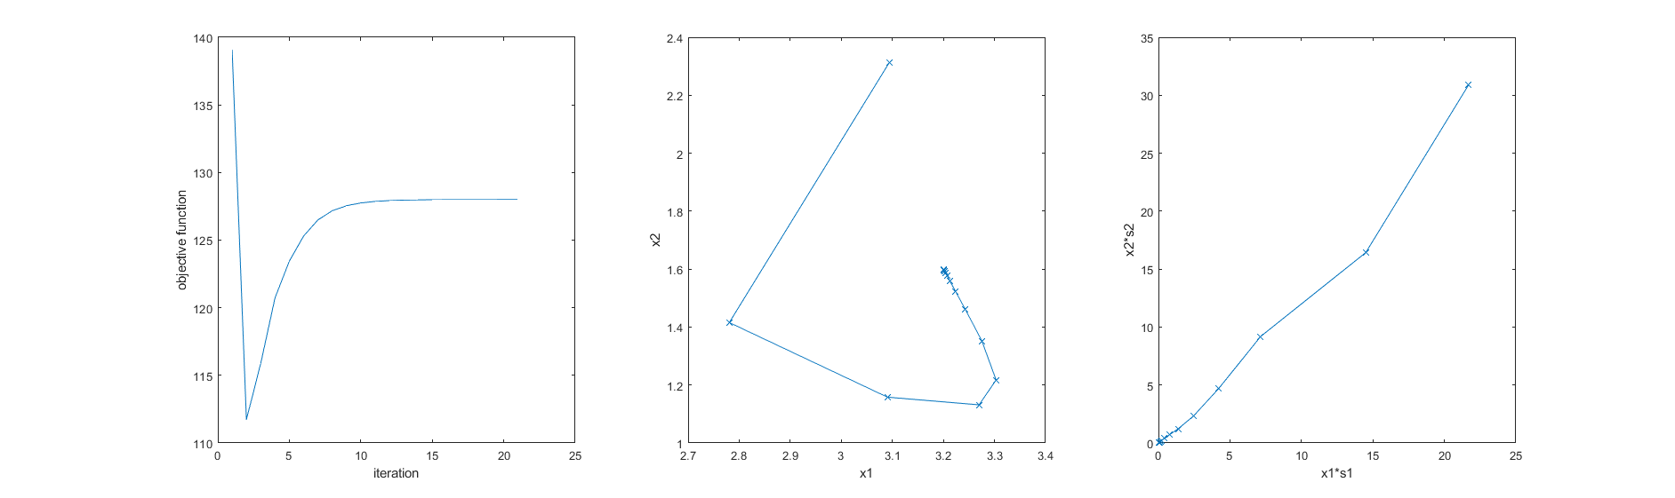

**Adaptive central**

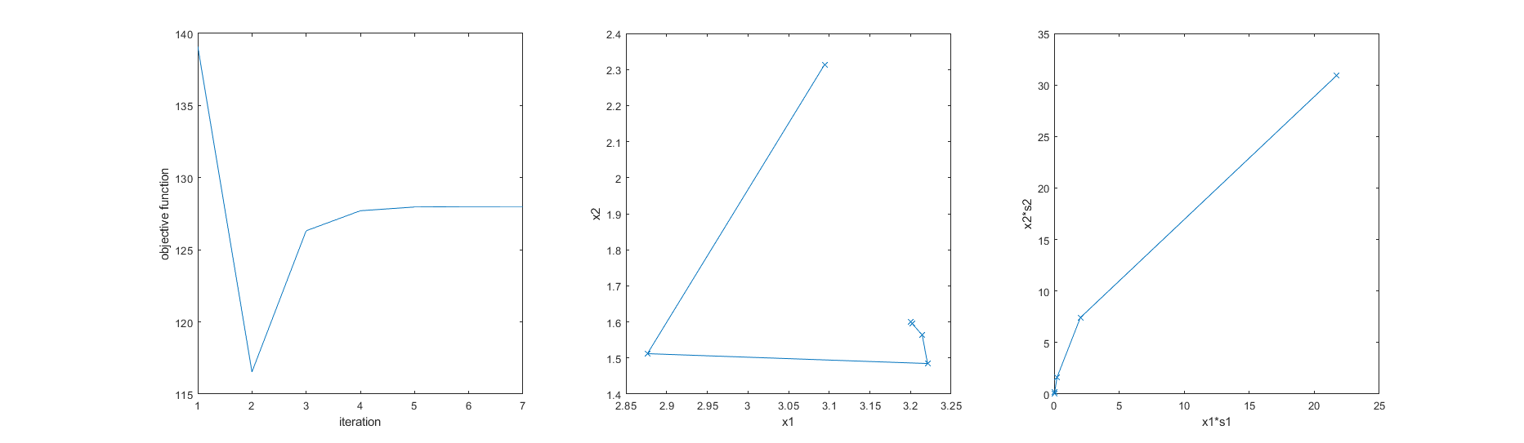

**Mehrotra**

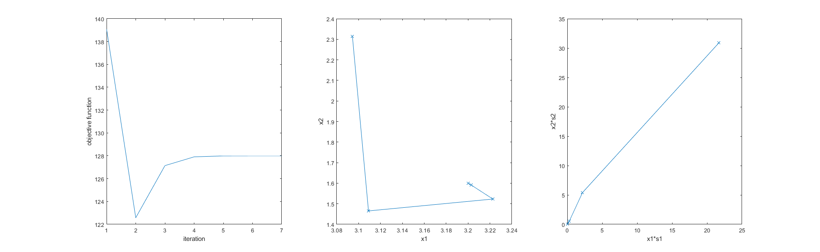

The fixed central path converges after 20 iterations to give the same results as Mehrotra and adaptive central path.

The built-in function gives the same results as Mehrotra and converges also in 7 iterations. On the other hand, my implementation of Mehrotra and adaptive central path converges in 6 iterations

Optimum point $=[3.2,1.6]$

With value = 128

**Second problem:**

$$\max{F=1.1x_{1}+x_{2}}$$

s.t

$$x_{1}+x_{2}≤6$$

$$x_{1},x_{2}≥0$$

**Fixed central**

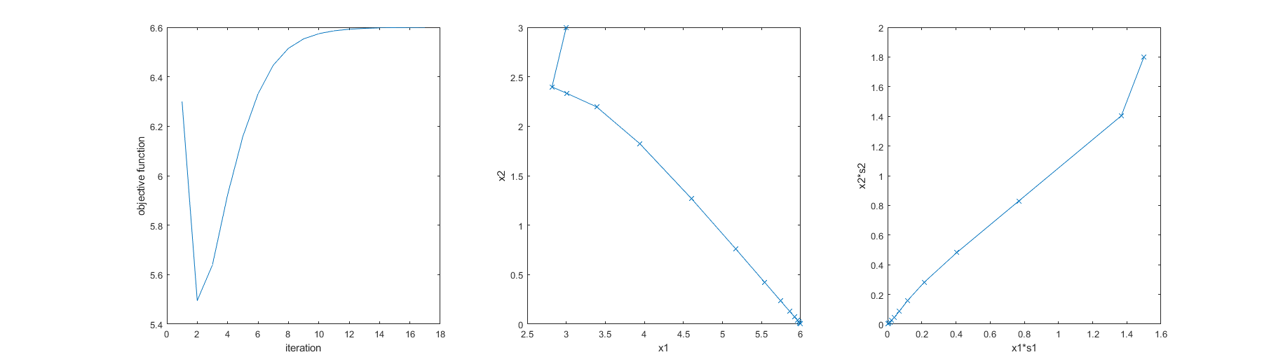

**Adaptive central**

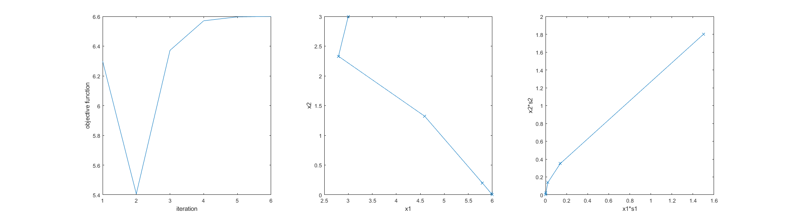

**Mehrotra**

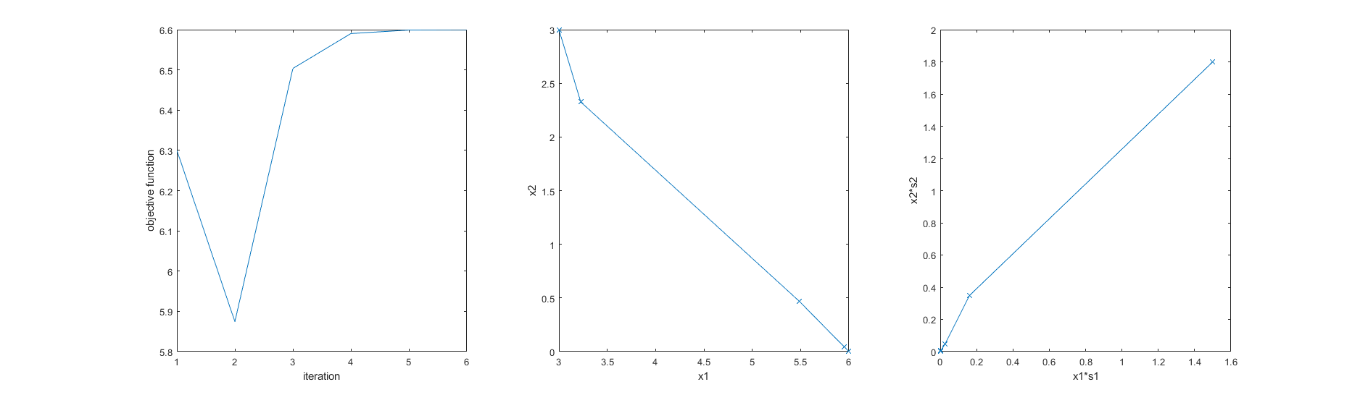

The fixed central path converges after 16 iterations to give the same results as Mehrotra and adaptive central path.

The built-in function gives the same results as Mehrotra and converges in 5 iterations the same as my implementation.

Optimum point $=[6,0]$

With value = 6.6

**Third problem:**

$$\max{F=x_{1}+2x_{2}+x_{3}}$$

s.t

$$2x_{1}+x_{2}-x_{3}≤2$$

$$-2x_{1}+x_{2}-5x_{3}≥-6$$

$$4x_{1}+x_{2}+x_{3}≤6$$

$$x_{1},x_{2},x_{3}≥0$$

Since this is a three-dimensional problem the complementary and point progress are hard to visualize so I only include the objective function

**Fixed central**

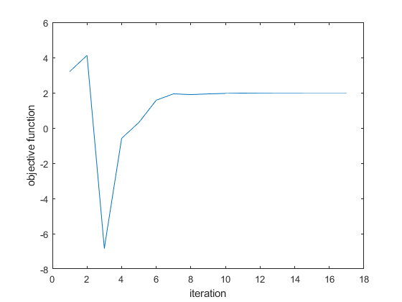

**Adaptive central**

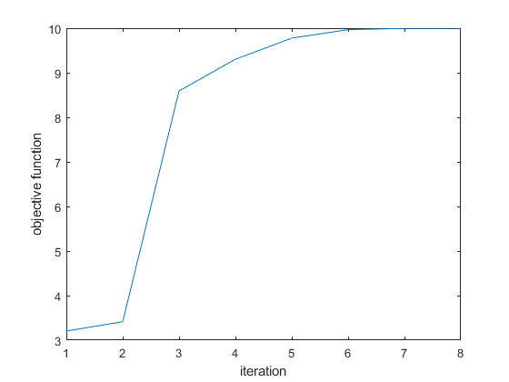

**Mehrotra**

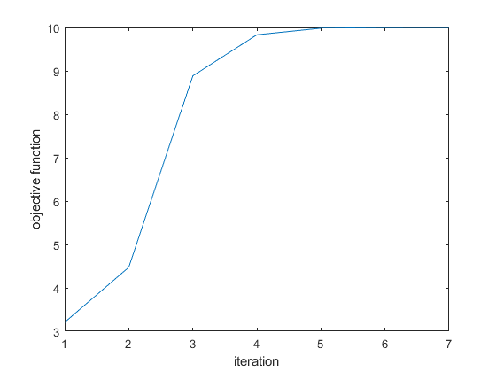

The fixed central path doesn’t converge because the fixed step size makes the non-negativity condition unsatisfied which terminates the program without reaching a solution

The built-in function gives the same results as Mehrotra and converges in 5 iterations. On the other hand, my implementation of Mehrotra converges in 6 iterations while adaptive central path converges in 7 iterations

Optimum point $=[0,4,2]$

With value = 10